MALAWI UNIVERSITY OF SCIENCE AND TECHNOLOGY
PHYS-111 Lecture 4 Tutorial questions
- A 15 kg bird feeder is supported by three cables as shown in Figure below. Find the tension in each cable.
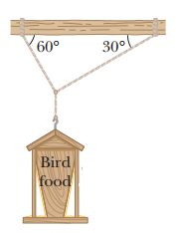
- A block lies on a smooth plane tilted at an angle 22⁰ to the horizontal.
  - Determine the acceleration of the block as it slides down the plane.
  - If the block starts from rest 9.10 m up the plane from its base, what will be the block’s speed when it reaches the bottom of the incline? Ignore friction.
- A block weighing 75 N rests on a plane inclined at 25ᵒ to the horizontal. A force F is applied to the object at 40ᵒ to the horizontal, pulling it upward on the plane. The coefficients of static and kinetic friction between the block and the plane are, respectively, 0.363 and 0.156. What is the minimum value of F that will prevent the block from slipping down the plane?
- John is pulling a sled to haul up a snowy hill to this cabin. The slope is 22⁰ from the horizontal, the sled has a mass of 16.0 kg, the coefficient of kinetic friction between the sled runners and the snow is 0.130, and John can exert a force of 1400 N parallel to the surface of the hill. What is the largest load of wood (in kg) that John can take in one trip?
- Two packing crates of masses 10.0 kg and 5.00 kg are connected by a light string that passes over a frictionless pulley as in Figure below. The 5.00-kg crate lies on a smooth incline of angle 40.0°.
- Find the acceleration of the 5.00-kg crate
- Find the tension in the string
- If the coefficient of static friction between the 5.00-kg crate and the 40.0° incline is 0.300. Find tension in the string and acceleration of the crate.
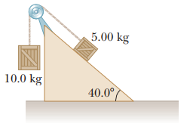
- Three objects are connected on a table as shown in Figure below. The coefficient of kinetic friction between the block of mass m2 and the table is 0.350. The objects have masses of m₁=4.00 kg, m₂=1.00 kg, and m₃=2.00 kg as shown, and the pulleys are frictionless. Determine the acceleration of each object, including its direction.
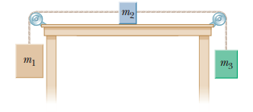
- Three objects are connected by light strings as shown in Figure below. The string connecting the 4.00-kg object and the 5.00-kg object passes over a light frictionless pulley. Determine (a) the acceleration of each object and (b) the tension in the two strings.
